**California Housing Prices**

* **Abstract**

The data relates to the houses in each area of ​​California and some summary statistics about them based on 1990 census data, the goal of this project is to implement machine learning (regression) algorithms, we will predict the housing prices based on the features.

* **Design**

**Q1-Does the age of the house effect on the house value?**

**Q2-What do people prefer on their house location?**

**Q3-Does the proximity of the house to the ocean affect its price?**

**Q4-What is the most city has the highest population?**

* **Data**

This is the dataset used in the second chapter of Aurélien Géron's recent book 'Hands-On Machine learning with Scikit-Learn and TensorFlow'. It serves as an excellent introduction to implementing machine learning algorithms because it requires rudimentary data cleaning, has an easily understandable list of variables and sits at an optimal size between being to toyish and too cumbersome.

The data contains information from the 1990 California census. So, although it may not help with predicting current housing prices like the Zillow Zestimate dataset, it does provide an accessible introductory dataset for teaching people about the basics of machine learning. the dataset is provided in .CSV format. containing 20,640 rows and 10 columns ([Kaggle](https://www.kaggle.com/camnugent/california-housing-prices)).

* **Algorithms**
* Problem understanding
* Data collection
* Data cleaning
* Explore data
* Build the model
* Train the model
* Evaluate the model
* Choose the right model (conclusion)
* **Tools**
* Pandas
* NumPy
* Matplotlib
* Seaborn
* Scikit-learn
* Math library
* Folium
* PowerPoint, Canva
* Zoom
* **Communication**

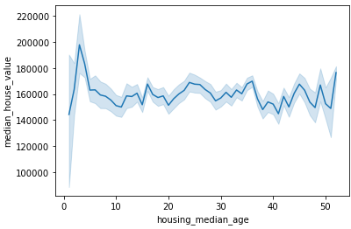

We noticed that the value of the houses is the highest when the age is between 0(new) to 5 years.

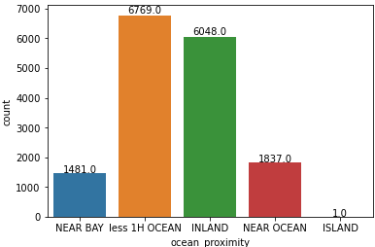

We noticed that most people prefer to live in houses that are less than 1 hour away from the ocean, and also some prefer it to be in land.

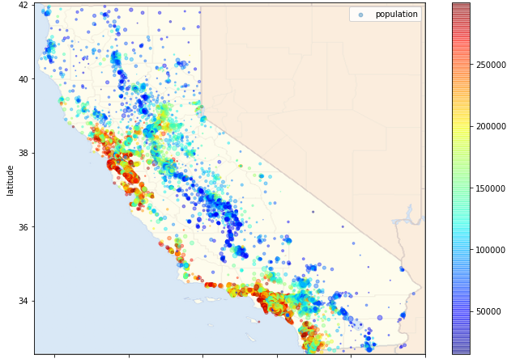

As we can see from the map that the closer, we are to the ocean, the more expensive the houses become.

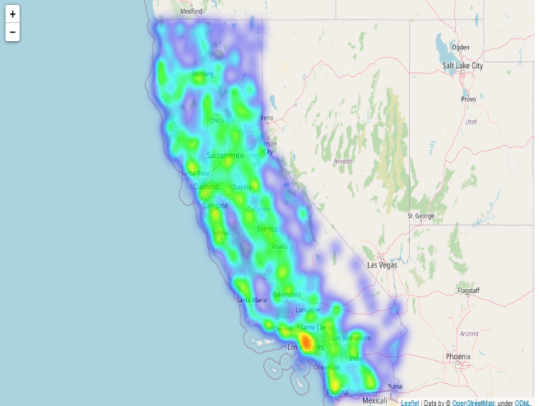

From the map we saw that los Angeles has more houses that the other cities

* **Authors**:

[Maha Aladwani](mailto:msealadwani@gmail.com)

[Yazeed Alharthi](mailto:Yazeed662@hotmail.com)

[Hala Alanzi](mailto:haloo.zz17@gmail.com)